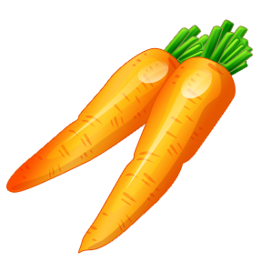
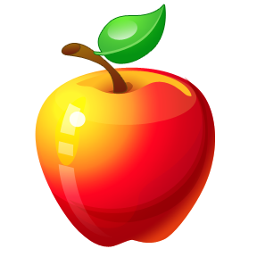
Week 1
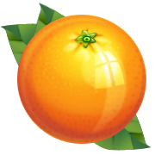
MEAL | MONDAY | TUESDAY | WEDNESDAY | THURSDAY | FRIDAY
1st SNACK | Chips & Salsa  • ¼ cup Tortilla Chips  • 1 T Salsa  • Carrots  Water | Garden Salad  • 1 cup lettuce  • ¼ cup croutons  1 T Ranch  Water | Pita & Hummus  • 3 Pita slices  • ¼ Carrots  • 1 T Hummus  Water | Turkey and Cream Cheese Roll-ups  • ½ Tortilla  • 1 Slice of Turkey  • 1 T Cream Cheese  Fruit or Veggie  Water | Quesadillas  [assembled in house]  • 1 tortilla wrap  • ¼ cup shredded cheese  • 1 T Salsa  Fruit or Veggie  Water
2nd SNACK | Wheat Thins  ¼ cup Wheat Thins  Leftovers | Ritz Crackers  ¼ cup Ritz Crackers  Leftovers | Gold Fish  ¼ cup Gold Fish  Leftovers | Pretzels  ¼ cup Pretzels  Leftovers | Cheese Its  ¼ cup Cheese Its  Leftovers
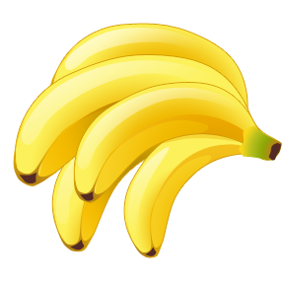
Week 2
MEAL | MONDAY | TUESDAY | WEDNESDAY | THURSDAY | FRIDAY
1st SNACK | Mini Bagels & Cream Cheese  • ½ Bagel  • 1 T Cream cheese  Fruit or Veggie  Water | Pretzels and Cheese Sticks  • 1 cup Pretzels  • 1 Cheese Stick  Water | Graham Crackers & Applesauce  • 2 Graham Crackers  • ½ cup Applesauce  Water | Toast and Tomato Soup  • ½ Slice of toast  • ¼ cup Tomato soup  Water | Cheesy Bread with Dipping Sauce  • ½ English muffin  •1 T Prego sauce  • ¼ cup shredded cheese  1 T Ranch  Water
2nd SNACK | Ritz Crackers  ¼ cup Ritz Crackers  Leftovers | Gold Fish  ¼ cup Gold Fish  Leftovers | Pretzels  ¼ cup Rice Crackers  Leftovers | Cheese Its  ¼ cup Cheese Its  Leftovers | Wheat Thins  ¼ cup Wheat Thins  Leftovers

