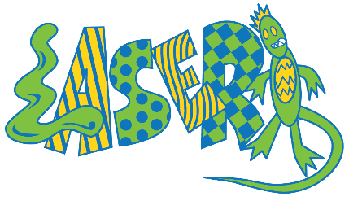
Summer Camp 2022
Field Trip Schedule

as of August 18th
 | Monday | Tuesday | Wednesday | Thursday | Friday
Week 1  (6/22 – 6/24)  Superhero | LASER Closed | LASER Closed | Ravenna Park | Emerald City Pirate Boats | Costume Party (Stay Back)
Week 2  (6/27 – 7/1)  Fantasy & Imagination | Museum of Pop | Museum of Flight | Maple Leaf Reservoir Park | Magician at LASER  (Stay Back) | Coulon Beach
Week 3  (7/5 – 7/8)  Wildlife Adventure | July 4th  LASER Closed | Seward Park | Remlinger Farm | Petting Zoo at LASER  (Stay Back) | Golden Gardens
Week 4  (7/11 – 7/15)  Cooking | Homemade Ice Cream  (Stay Back) | Lincoln Park | Oxbow Farms | Ice Cream Creation  (Stay Back) | Juanita Beach
Week 5  (7/18 – 7/22)  Hot Wheels | Wheel Fun  At Alki Beach | Build Tracks &  Race  (Stay Back) | Carkeek Park | Family Fun Center | Chism Beach Park
Week 6  (7/25 – 7/29)  Mad Science  /STEM | Rube Goldberg Machines (Stay Back) | Rock Sciences at LASER  (Stay Back) | Discovery Park | WA Park Arboretum | Coulon Beach
Week 7  (8/1 – 8/5)  Harry Potter | Harry Potter Movie: The Sorcerer’s Stone | Bellevue Botanical Garden and Larson Blueberry farm | Edmonds City Park | Harry Potter Costume Party & Handmade Recycled paper  (Stay Back) | Medina Beach
Week 8  (8/8 – 8/12)  Master Builder | KidsQuest:  Engineering Force with Hydraulics | Egg Drop at LASER | St. Edwards Park | Model Car  (Stay Back) | Kennydale Beach Park
Week 9  (8/15 – 8/19)  Splashtacular (Please pack swim gear!) | Henry Moses  Aquatic Center | Ballard Locks Tour | Luther Burbank Park | Seattle Aquarium | Madrona Beach Park
Week 10  (8/22 – 8/26)  Exploring Our Past | 3rd – 6th : Seattle Underground Tours | Madrona Beach  (Weather Dependent) | Family Fun Center | Time Travel Projects  (Stay Back) | Paper Jet Launcher  (Stay Back)
K – 2nd :
Wing Luke Museum
Week 11  (8/29 – 8/31)  End of Summer Bash | Rockets at LASER | Carnival at LASER | Games, Games, Games!  (Stay Back) | LASER Closed | LASER Closed

*Please note that some field trips have yet to be confirmed by the venue, therefore, the schedule above is subject to change. We will provide any updates to changes as we get more information. Thank you for understanding!

Highlighted Cells are Stay Back Days

